**ASSIGNMENT 4 (MODERN HTML ASSIGNMENT)**

1. **List out the features of HTML5.**

**Ans 1**) Features of HTML5 are: -

**1. Semantic Elements**

When constructing an HTML script, the term “**semantic**” refers to the meaning of the text. **Semantics** is the use of HTML tags that accurately reflect the content they contain. For instance, using the **<div>** tag doesn’t suggest the content it will carry, however using the **<p>** tag suggests it can be used to hold paragraph information.

There are a lot of reasons why you should write Semantic tags instead of normal HTML tags, to leverage SEO, accessibility, and browser compatibility.

**2. Audio and Video Support**

One of the many HTML 5 features is the support for audio and video. It has reduced the hassle of relying upon third-party services such as Adobe Flash player. To embed Audio and Video into your HTML document, you may use the following two tags, <**audio>** and **<video>** tags.

These two tags are launched with the release of HTML 5 and support a numerous range of attributes such as height, width, and more that offers developers to leverage the customization of HTML documents.

**3. Canvas Elements**

Canvas Elements is a top-notch feature that has made the tedious task of handling graphics easier for developers. With the help of Canvas elements, you can easily draw graphics using JavaScript. It is optimum for creating simple animations and drawing photo compositions.

To initialize the Canvas element **<canvas>** tag is used with only two specific attributes, width and height. Once, the element is initialized, it is then taken care of with the help of JavaScript to draw shapes, lines, images, and more.

**4. Geolocation API**

The **Geolocation** API is an HTML feature that is used to access the geographical position of a user; however, it is not accessed unless the user approves of it. If you’re wondering where this feature is useful, these come in handy while creating apps like taxi apps, food order tracking apps, fitness tracking apps, and more.

**5. Local Storage**

It is a modern feature of HTML and several browsers that typically store data in the user’s browsers and can access them with the help of JavaScript APIs. This feature is useful for creating offline applications where data is need to be stored locally.

Moreover, using this feature you can reduce the transactions between the application and the backend server, creating a fast application. However, there are some limitations, such as there is limited storage, and you cannot access more storage than that.

**6. Responsive Images**

Earlier to create responsive images on the web, you have to rely upon several lines of CSS and sometimes JavaScript, however, HTML 5 makes the process handy by including **srcset** attribute to specify multiple versions of an image at different screen resolutions.

**7. Web Workers**

When you are performing several demanding tasks at once, the browser gets sluggish and responds slowly. Because of this, web workers were added to HTML 5 to allow scripts to operate in the background without interfering with the UI thread.

This may be used to execute demanding operations like multimedia processing in the background. To further demonstrate the usage of Web Workers, we shall create a simple counter app that starts the counter when you click **‘start’** and stop the counting when you click **‘stop’**.

**8. Form enhancements**

HTML 5 introduces new features for your existing forms on HTML to create a more robust user experience. Some of the key enhancements in the new HTML 5 include new input times such as email, URL, and more, placeholder text, required fields feature, validation, and more.

1. **What are HTML Entities? List out 5 commonly used HTML Entities.**

**Ans 2)** **HTML Entities:** HTML entities are special codes that represent reserved characters, symbols, or characters with specific meanings in HTML. They are used to display characters that might otherwise be interpreted as HTML code or cause rendering issues in web browsers. HTML entities are written using an ampersand (&) followed by a specific code or name, and ending with a semicolon (;).

**5 Commonly Used HTML Entities:**

1. &lt; : Represents the less-than symbol <.

Example: - <h2>The less-than sign: &lt;</h2>

1. &gt; : Represents the greater than symbol >.

Example: - <h2>The less-than sign: &gt;</h2>

1. &amp; : Represents the ampersand symbol &.

Example: - <h2>The ampersand (and) sign: &amp;</h2>

1. &copy; : Represents the copyright symbol ©.

Example: - <h2>The ampersand (and) sign: &amp;</h2>

1. &quot; : Represents the double quotation mark symbol “.

Example: - <h2>The double quote sign: &quot;</h2>

1. **Define accessibility in the context of web development. Discuss why it’s essential to create accessible websites and how it benefits different user groups.**

**Ans 3)** Accessibility of Web development is essential for developers and organizations who want to create high-quality websites and tools, as they should not exclude people from using their products and services.

Web accessibility means that websites, tools, and technologies are designed and developed so that people with disabilities can use them. More specifically, people can:

* perceive, understand, navigate, and interact with the Web
* contribute to the Web

Web accessibility encompasses all disabilities that affect access to the Web, including:

* auditory
* cognitive
* neurological
* physical
* speech
* visual

**Importance of Accessible Websites:**

* **Inclusivity**: Accessible websites ensure that everyone, including people with disabilities, can access and use online information and services.
* **Legal** **Compliance**: Many countries have laws requiring websites to be accessible, avoiding legal issues and promoting equal access.
* **User** **Experience**: Accessible design often leads to improved user experiences for everyone, including clear navigation and content structure.
* **Business Growth**: Accessible websites reach a wider audience, increasing engagement, loyalty, and potential customer base.

**Benefits for User Groups**:

* **Visual Impairments**: Accessibility provides screen reader support and text alternatives, aiding blind and visually impaired users.
* **Hearing Impairments:** Captions and transcripts benefit those with hearing impairments by making audio content understandable.
* **Motor Disabilities:** Keyboard navigation and easy-to-click elements assist users with motor limitations.
* **Cognitive Disabilities:** Accessible design simplifies content and layout, aiding individuals with cognitive challenges.
* **Elderly Users**: Accessible websites accommodate age-related limitations, ensuring usability for elderly users.
* **Mobile Users**: Accessible design improves mobile experiences through simplified and responsive layouts.

1. **List any 3 ways which help us in improving the accessibility of HTML.**

**Ans 4) 3 ways which help in improving the accessibility of HTML are:**

**Use Semantic HTML Elements**: Using semantic HTML elements helps improve accessibility by providing meaningful structure to your content. Semantic elements like <header>, <nav>, <main>, <article> and <footer> convey the purpose of different sections to assistive technologies, making it easier for users with disabilities to navigate and understand the content

**Provide Alt Text for Images:** Adding descriptive alt text to images using the alt attribute ensures that users who cannot see the images can understand their content and purpose. Screen readers read aloud the alt text, making visual content accessible to people with visual impairments. Aim to make alt text concise, informative, and relevant to the image.

**Use Color with Care:** Color plays an important role in web design, but it should not be the only means of conveying information. Ensure that color is not the sole indicator of meaning. For example, when using error messages, pair color with text that explains the error. Additionally, maintain sufficient color contrast between text and background to enhance readability for users with low vision.

1. **Create a web page that highlights the features of HTML5. Use appropriate semantics tags to structure the content and showcase at least three key features of HTML5 with explanations.**

<!DOCTYPE html>

<html lang="en">

<head>

    <meta charset="UTF-8" />

    <meta name="viewport" content="width=device-width, initial-scale=1.0" />

    <title>HTML5 Features Showcase</title>

    <style>

        .s1{

            display: flex;

            padding: 20px;

        }

    </style>

</head>

<body>

    <header>

        <h1>Features of HTML5</h1>

    </header>

    <section>

        <h2>1: Audio & Video Support</h2>

         <p>

            HTML5 introduced the <code>&lt;aduio & video&gt;</code> element for embedding audios and videos directly in web pages.

        </p>

        <div class="s1">

            <audio src="/audio.mp3" controls></audio>

            <video width="400" controls style="width: 35em; height: 20em;">

                <source src="/video.mp4" type="video/mp4"/>Your browser does not support the video tag.

            </video>

        </div>

    </section>

    <section>

        <h2>2: Form Validation</h2>

        <p>HTML5 offers built-in form validation, reducing the need for custom JavaScript code.</p>

        <form class="s1">

            <label for="email" style="font-size: 21px; margin-right: 20px; MARGIN-TOP: 5px;">Email:</label>

            <input type="email" id="email" required style="margin-right: 20px; width: 25%;"/>

            <br />

            <input type="submit" value="Submit" style="width: 80px; padding: 7px;" />

        </form>

    </section>

    <section>

        <h2>3: Semantic Tags</h2>

        <p>HTML5 introduced semantic tags like <code>&lt;header&gt;</code>,<code>&lt;nav&gt;</code>,

            <code>&lt;main&gt;</code>, and more, which improve page structure and accessibility.</p>

        <article>

            <h3>Article Title</h3>

            <p>Lorem ipsum dolor sit amet consectetur adipisicing elit. At autem a veritatis delectus ducimus, sapiente ut labore? Perspiciatis quasi dolores labore cupiditate cumque ab modi est voluptates quia corrupti. Aliquid. </p>

        </article>

    </section>

    <footer>

        <p>Created by Mansi Srivastava &copy; 2023</p>

    </footer>

</body>

</html>

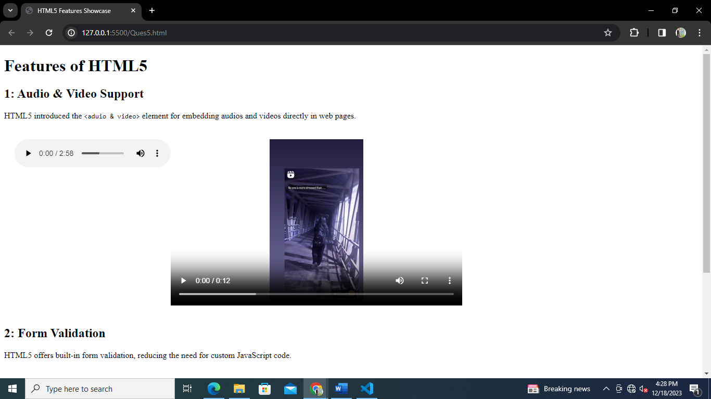**OUTPUT: -**

1. **Create a web page that which has a table. The table must have 2 columns HTML and HTML5. The table should include a minimum of three rows describing the differences between HTML and HTML5.**

<!DOCTYPE html>

<html lang="en">

  <head>

    <meta charset="UTF-8" />

    <meta http-equiv="X-UA-Compatible" content="IE=edge" />

    <meta name="viewport" content="width=device-width, initial-scale=1.0" />

    <title>HTML v/s HTML5</title>

  </head>

  <body>

    <h1>HTML v/s HTML5</h1>

    <table border="1">

      <thead>

        <tr>

          <th>HTML</th>

          <th>HTML5</th>

        </tr>

      </thead>

      <tbody>

        <tr>

          <td>It didn’t support audio and video without the use of flash player support.</td>

          <td>It supports audio and video controls with the use of <audio> and <video> tags.</td>

        </tr>

        <tr>

          <td>It uses cookies to store temporary data.</td>

          <td>It uses SQL databases and application cache to store offline data.</td>

        </tr>

        <tr>

          <td>Vector graphics is possible in HTML with the help of various technologies such as VML, Silver-light, Flash, etc.</td>

          <td>Vector graphics is additionally an integral a part of HTML5 like SVG and canvas.</td>

        </tr>

        <tr>

          <td>It does not allow drag and drop effects.</td>

          <td>It allows drag and drop effects.</td>

        </tr>

        <tr>

            <td>Doctype declaration is too long and complicated.</td>

            <td>Doctype declaration is quite simple and easy.</td>

          </tr>

          <tr>

            <td>Does not allow JavaScript to run in browser.</td>

            <td>Allows JavaScript to run in background. This is possible due to JS Web worker API in HTML5.</td>

          </tr>

          <tr>

            <td>It is almost impossible to get true GeoLocation of user with the help of browser.</td>

            <td>One can track the GeoLocation of a user easily by using JS GeoLocation API.</td>

          </tr>

          <tr>

            <td>It has fewer elements as compared to HTML5.</td>

            <td>It includes new elements and form attributes such as time, date, and colour. Required and autofocus in input types of the tag element as well.</td>

        </tr>

      </tbody>

    </table>

  </body>

</html>

**OUTPUT: -**

